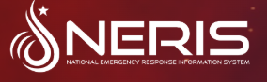

NERIS Introduction Training

August 21, 2025

6-8 pm

Public Services Building
Eastern Oklahoma County Technology Center
Choctaw, Oklahoma
Room EMT 1

This training session will be an overview of the new NERIS reporting software that was signed into law (House Bill 1052). Effective, November 1, 2025. All Oklahoma fire departments are mandated to transition their incident reporting to the National Emergency Reporting Information System (NERIS).

Please call Erick Reynolds at 405-390-9592 or Dana Robertson at 405-390-5315 to enroll!!
Class Cost: $0.00

